EUMM
European Union Monitoring Mission
Krtsanisi Residential Area, 49 Krtsanisi Street, 0114 Tbilisi, Georgia
Tel: + 995 (8) 32243719, Fax: + 995 (8) 32243718
www.eumm.eu

CLARIFICATION NOTE N° 1

to the tender dossier for the supply, delivery, installation and commissioning of generators and stabilizers at various premises operated by the EUMM Georgia

Publication Ref: EuropeAid/138207/DH/SUP/GE
Contract N°: EUMM-16-4553
Location: Georgia (GEO)

With reference to the above-mentioned tender procedure, please find below the written questions raised by prospective bidders and the corresponding answers given by the EUMM

Nº | Question | Answer
1 | Please advise how many power supplies are currently supplying the HQ.  Note from the EUMM: HQ = Headquarters | 2 to main HQ building, 1 to Warehouse (which is irrelevant).

Nº | Question | Answer
2 | Please advise if there is sufficient access into the switchroom to install the proposed stabilizer. | Proposed installation (recently agreed with Telasi AFTER tender site visit) is outside (outdoors) next to the Telasi Transformer, under an EUMM made shelter, Telasi will provide connection from their Transformer through one consumption reading meter to the 500 kVA Stabiliser/Generator setup which will be next to the Stabilizer.  (Telasi = Power distribution company)

Nº | Question | Answer
3 | What is the required switching arrangement between each generator and the Telasi supply? | Remains the same as is now.

Nº | Question | Answer
4 | Is the cable routing between the HQ and the lower offices in this scope? | Cables will remain from the Transformer to all areas, and the 500 kVA Generator and Stabilizer will be connected directly to the Transformer.

Nº | Question | Answer
5 | Will civils works if required for cable installations be performed by others? | By the EUMM.

Nº | Question | Answer
6 | Indicate if the electric connection scheme is solution 1 or solution 2 of the annex_1 attached.  Note from the EUMM: The annex_1 referred to above has been deliberately omitted by the EUMM as irrelevant. | Neither. See schematic drawings (HQ Generator Stabilizer Cabling Schematic final) contained in the Appendix A to the Site Visit Minutes and see also the drawing showing layout and distances that is provided at the end of this document.

Nº | Question | Answer
7 | Is it necessary to supply the electric commutation switchboard Grid/Generator? | One Changeover or Automatic Transfer Switch or ATS (panel/switch/system) to be provided for each new Generator so totaling 5, specific for each generator size.

Nº | Question | Answer
8 | Is it necessary to build any concrete bases to place the Generators? | No.

Nº | Question | Answer
9 | Is the placement of the Generators outdoor for each of item? If not, is it necessary to do some civil works like demolition of any walls, for example, in order to put them inside in the technical room? | Yes, all generators are placed outdoors.

Nº | Question | Answer
10 | Is it necessary to supply all types of interconnection cables (Generator/Grid/Load) for all expected components by Tender? | Yes, for cables from generators to Switch Board/Distribution Panels, Changeovers (ATS) & Stabilizers (Schematic drawings shows distances of new cables needed for each generator but the HQ 450-500 kVA Generator/Changeover/Stabilizer needs only under 20 meters of cable as it is now to be positioned next to the Transformer).

Nº | Question | Answer
11 | Is it possible to receive a lay-out of the installation sites/room? | See schematic drawings (HQ Generator Stabilizer Cabling Schematic final) contained in the Appendix A to the Site Visit Minutes and see also the drawing showing layout and distances that is provided at the end of this document.

Nº | Question | Answer
12 | Is it necessary to realize the electric ducts or overhead pipes to connect the Generators to the loads? And in this case what is the distance between generator and the loads in the following cases:  Mtskheta (power generator of 80 kVA) (electric duct mt ____, overhead pipes mt ____)  Gori (power generator of 80 kVA) (electric duct mt ____, overhead pipes mt ____)  Zugdidi (power generator of 80 kVA) (electric duct mt ____, overhead pipes mt ____)  Tbilisi (power generator of 250 kVA) (electric duct mt ____, overhead pipes mt ____)  Tbilisi (power generator of 400 kVA*) (electric duct mt ____, overhead pipes mt ____)  Tbilisi (relocation of old power generator 250 kVA) (electric duct mt ____, overhead pipes mt ____)  * Note from the EUMM: Minimum generator capacity should be 450 kVA | See schematic drawings (HQ Generator Stabilizer Cabling Schematic final) contained in the Appendix A to the Site Visit Minutes and see also the drawing showing layout and distances that is provided at the end of this document.

EUMM Headquarters Schematic Cable & Electrical System Drawing

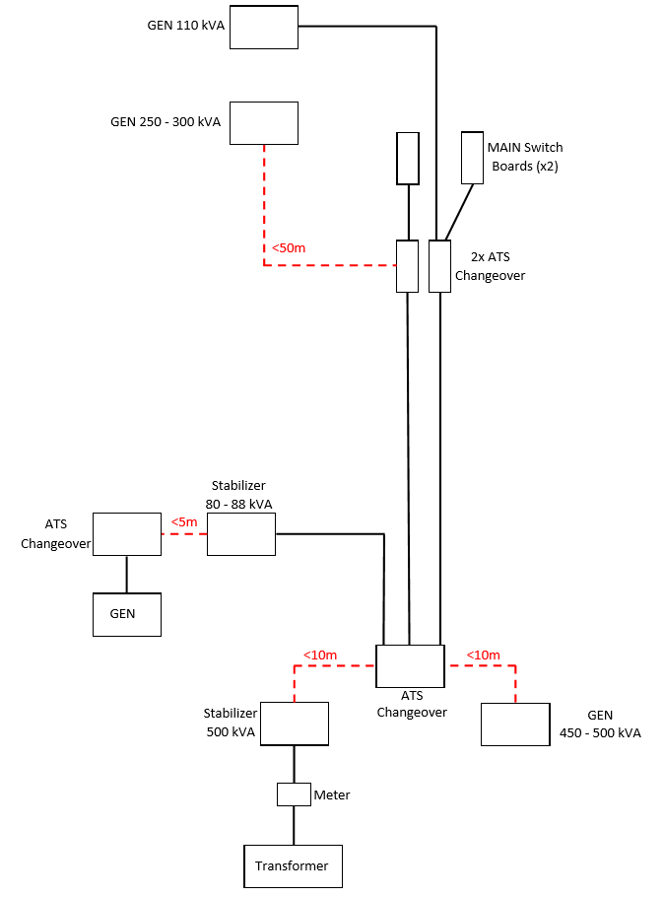

In dashed lines are those cables that must be supplied by the winning bidder, showing the amount required in less than meters (ie ˂ 10 m). All other cables in solid lines are existing.

